**Curriculum Vitae**

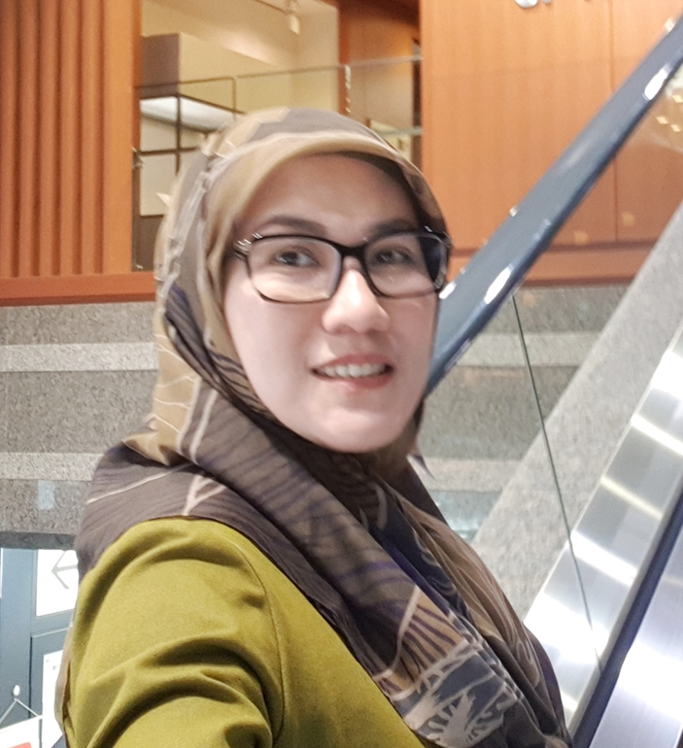

Dr Yetty Movieta Nency SPAK

Nama : **Yetty Movieta Nency**

**Em**ail : ***yettymn@yahoo.com / yettymn@gmail.com***

**Keahliann :**

* **Konsultan Hematologi Onkologi Anak**
* **Konsultan Laktasi Internasional / IBCLC**
* **Peneliti**

**Posisi : Staf Pengajar di Fakultas Kedokteran UNDIP**

**Ketua Bag Ilmu Kesehatan FK UNDIP Semarang**

**Alamat : Prabanata village Blok D9-10 Banyumanik Semarang**

**Pendidikan:**

Consultant of Pediatric hematology Oncology (2012)

International Board of Certified Lactation Consultant / IBCLC (2011- now)

Oncology Fellowships: National Cancer Center, Tokyo , Japan 2010

IARC (WHO) Summer school on Cancer epidemiology, Lyon, France 2008

WHO Cancer Registry, Lyon , France, 2008

Pheripher and bone marrow morphology reading Competency . Netherlands 2008

Oncology Trainneships : VUMC Netherlands 2005 , 2007

Dokter spesialis anak, Medical Faculty, Diponegoro University, Semarang Indonesia (2005)

**Aktifitas Penelitian :**

* Penelitian Vaksin Covid 2020
* Penelitian vaksin Hep B – Biofarma 2019 – 2020
* Penelitian Benzena pada anak Leukemia 2018-2020
* Penelitian anemia defisiensi besi pada remaja 2020
* Evaluation Of The Leukemia Protocol Acute In Indonesia 2013
* Research On Breastfeeding On Leukemia 2014
* Filter Transfusion In Patients Leukemia 2015
* Penelitian Cost effectiveness protokol Leukemia 2012-2016

**Publikasi:**

1. Relapse In All Treated With Wk All Protocol. Proceeding Book St Jude Viva Forum Singapore. 2009.
2. Transfussion Requirements During Induction Phase In All Treated With Indonesian Protocol. Proceeding Book St Jude Viva Forum Singapore. 2010
3. Hubungan Latar Belakang Penyakit Dengan Utilisasi Transfusi Komponen Darah Di Ruang Anak Rs Dr Kariadi Semarang. Saripediatri. 2011
4. Perbedaan Kebutuhan Transfusi Darah Selama Fase Induksi Pada Pasien Lekemia Limfositik Akut Risiko Standar Dan Tinggi Yang Diterapi Dengan Protokol Indonesia 2006. Sari Pediatri 2011.
5. Immuno- Phenotypic Pattern Of Childhood Acute Leukemias In Indonesia. Asian Pacific Journal Pf Cancer Prevention Vol 12.2011
6. Efficiency Of The Indonesian 2006 Protocol In Childhood All. Proceeding Book St Jude Viva Forum Singapore. 2011
7. Time To Diagnosis Of All In Semarang. Proceeding Book St Jude Viva Forum Singapore. 2012
8. Five Year Evaluation Of The Indonesian Acute Lymphoblastic Leukemia 2006 Protocol Of The Pediatric Hematology Oncology Working Group. Proceeding Book St Jude Viva Forum Singapore. 2013
9. Acute Leukemia As Predominantly Using Blood Product In Pediatric Ward. Pediatric Blood And Cancer. 2015
10. Event Free Survival Enam Bulan Kejadian Tumor Cachexia Syndrome Pada Anak Dengan Keganasan. Sari Pediatri 2015.
11. Advancing Access And Equity: The Vision Of A New Generation In Cancer Control. Lancet Oncology. 2017
12. Exposure To Pollutant And Pesticide As A Risk Factor Of Childhood Leukemia. Proceeding Book St Jude Viva Forum Singapore. 2018
13. Correlation Of Parental Occupational Exposure To Benzene With Childhood Leukaemia Through Measurement Of Trans, Trans-Muconic Acid In Urine. Proceeding Book St Jude Viva Forum Singapore. 2018.
14. Faktor-Faktor Yang Mempengaruhi Prestasi Belajar Pasien Talasemia Mayor Anak

Diagnosis Challenge In Childhood Cancer In Indonesia. Diagnosis Challenge In Childhood Cancer In Indonesia Dalam Kegiatan 2018 Fluorescence In-Situ Hybridization (Fish) Seminar: Precision Medicine In Haematology And Solid Tumour Di Malaysia 23 Oktober 2018)

1. Translational Medicine In Indonesia. Conference On Global Globin 2020 Challenge (Gg2020 Conference 2018), Precision Medicine In Thallasemia In Malaysia 7 - 8 Juli 2018)
2. Aiha (Autoimmune Hemolytic Anemia) : Problem Of Diagnosis. Problem Of Diagnosis Dalam Kegiatan 16th Asia Pasifik Congress Of Pediatric (Apcp) 2018 , Pit Ika 218 ( Sdgs And Reducing Inequalities: How Far Have We Come) Di Bali 25 - 29 Agustus 2018
3. Faktor – Faktor Yang Mempengaruhi Pertumbuhan Anak Penderita Talasemia Mayor Di Jawa Tengah Indonesia Journal Kedokteran Diponegoro. 2018.
4. Mutation Spectrum Of Α And Β Globin Genes In Thalassemia Hemoglobinopathy In Central Java .Asia Pasific Iron Overload Workshop. Yogjakarta 2019
5. Association Between Low Birth Weight (Lbw) Infants And Th Incidence Of Acute Leukemia In Children. Jurnal Kedokteran Diponegoro 2020
6. Global Retinoblastoma Presentation And Analysis By National Income Level. Jama Oncol 2020 May 1;6(5):685-695
7. Effect Of Senam Sehat Anak Indonesia In Maximum Oxygen Consumption In Childhood Obesity. Jurnal Kedokteran Diponegoro 2020.

**Buku yang ditulis :**

1. Pitfalls In Pedaitric Daily Practice. Buku Cpd Xi Online Ika Fk Undip - Rsdk - Idai Jawa Tengah Dengan Judul "Pitfalls In Pedaitric Daily Practice" ( Editor)
2. Buku Ajar Hematologi Onkologi Idai 2018. ( Writer And Editor)
3. Buku Ajar Ilmu Kesehatan Anak. Fk Undip. 2018 ( Writer)
4. Menjaga Kualitas Hidup Jangka Panjang Remaja Pasca Kanker. 2017 (Writer)
5. Buku Update Tata Laksana Kejang Dan Perdarahan Pada Bayi Dan Anak. 2013 ( Writter)
6. Anemia Pada Remaja: Mengapa Dan Bagaimana. Naskah Simposium Pararel Dan Temu Ahli Pit Idai Ke 7. 2015 (Writer)
7. Buku Profesionalisme Dalam Praktek Klinis Dan Imunisasi. 2015 ( Writer And Editor)
8. International Seminar And Workshop On Modern Biology. 2011 ( Editor)
9. Breastfeeding Update In Daily Practice. 2013 (Writer )

**Penghargaan :**

* The Best Poster: Viva Forum Oncology 2012 Singapore.
* The Best Poster Pit Ika .2013
* The Highest Impact Factor Researcher Fk Undip. 2017