A | INCIDENT INFO/ INCIDENT NOTIFICATION WITHIN 12 HOURS
 | Title |  |  |  |  | Location |  |  |  | Date |  |  |  | Type of Incident (FAI/MTI/LTI/PD/ENV/NM/PB) |  |  |  |  |  | Class
1
B | ACHIEVEMENT OF LEADING INDICATOR
 | Department / Contractors |  | Daily
 |  |  | Oxycutting Inspection |  | OK KAN |  |  | TAKE ON 8 | Spot Check Vehicle |  |  | FE inspection | Work Permit Verification |  |  | Power Tools Inspection |  | Work Permit Compliance Inspection
1 | HSE |  | 4 |  | 9 |  |  | 51 | 5 |  |  | 8 | 69 |  |  | 5 |  | 2
C | HAZARD REPORT STATUS (KEEP REPORTED WHEN ITS STATUS IS STILL OPEN)
No | Hazard Date | Reported By -> Hazard Desc ->  Action to do -> Location |  | Category |  |  | Picture |  |  |  |  |  |  |  |  |  | Resp Dept - Person |  | Status
 |  |  |  |  |  |  | Open |  |  |  | Closed |  |  |  | Due Date
1 | 15 Mei 2024 | Reported by : Munir (HSE)  Hazard Desc: Koordinasi dengan PIC utk mereposisi sebagian pipa HDPE yg menghalangi akses  Action To Do: merapikan kabel pipa tersebut  Location : MCC 5416 |  | Housekeeping |  |  | 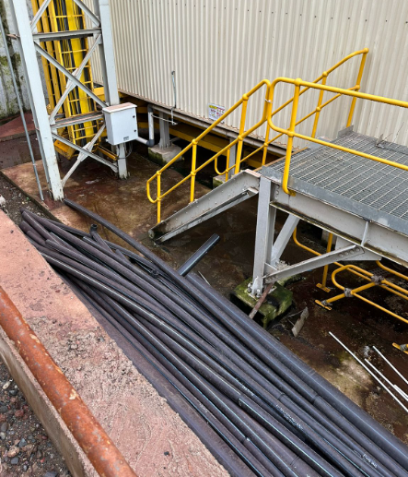 |  |  |  |  |  |  |  | 17 Mei 2024 |  | Piping |  | Open
2 | 30 Mei 2024 | Reported by : Munir (HSE)  Hazard Desc: Serpihan-serpihan sampah kecil berserakan di pinggir akses utama  Action To Do: Perlu housekeeping  Location : 4313 Main Access |  | Housekeeping |  |  | 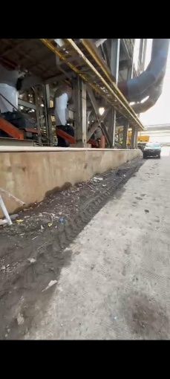 |  |  |  |  |  |  |  | 13 Juni 2024 |  | AGI, Mechanical, Piping |  | Open
3 | 30 Mei 2024 | Reported by : Munir (HSE)  Hazard Desc: Material tower crane menghalangi akses pintu keluar  Action To Do: Perlu digeser menjauh dari akses  Location : 4302 |  | Material Storage |  |  | 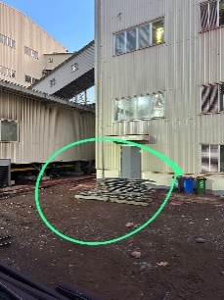 |  |  |  | No Pict |  |  |  | 13 Juni 2024 |  | Risca |  | Closed
5 | 30 Mei 2024 | Reported by : Munir (HSE)  Hazard Desc: Struktur scaffolding tanpa tagging  Action To Do: Perlu diinspeksi dan diberi tagging  Location : 4303 Selatan |  | Scaffolding |  |  | 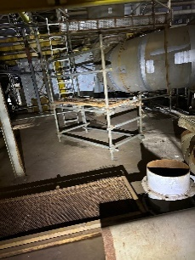 |  |  |  |  |  |  |  | 13 Juni 2024 |  | Risca |  | Open
6 | 30 Mei 2024 | Reported by : Munir (HSE)  Hazard Desc: Struktur scaffolding tanpa tagging  Action To Do: Perlu diinspeksi dan diberi tagging  Location : 4303 Selatan |  | Scaffolding |  |  | 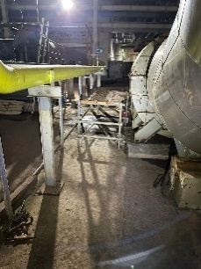 |  |  |  |  |  |  |  | 13 Juni 2024 |  | Risca |  | Open
7 | 1 Juni 2024 | Reported by : Munir (HSE)  Hazard Desc: Struktur scaffolding belum update inspeksi  Action To Do: Perlu diinspeksi  Location : 4306 |  | Scaffolding |  |  | 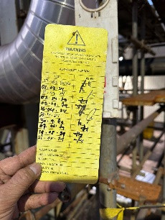 |  |  |  | 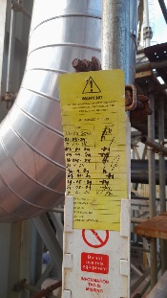 |  |  |  | 1 Juni 2024 |  | Risca |  | Closed
8 | 1 Juni 2024 | Reported by : Munir (HSE)  Hazard Desc: Rak oxy-acetyl menghalangi akses  Action To Do: Perlu direposisi  Location : 4307 |  | Material Storage |  |  | 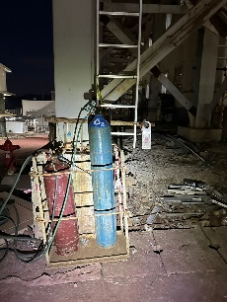 |  |  |  | 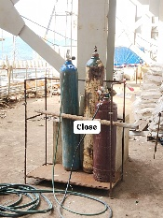 |  |  |  | 1 Juni 2024 |  | AGI |  | Closed
9 | 1 Juni 2024 | Reported by : Munir (HSE)  Hazard Desc: Struktur scaffolding belum update inspeksi  Action To Do: Perlu diinspeksi  Location : 4306 |  | Scaffolding |  |  | 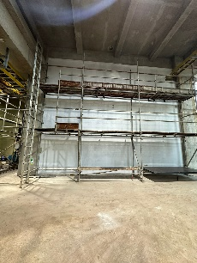 |  |  |  | 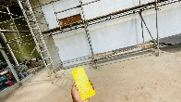 |  |  |  | 1 Juni 2024 |  | Risca |  | Closed
10 | 1 Juni 2024 | Reported by : Munir (HSE)  Hazard Desc: Scrap berhamburan  Action To Do: Perlu housekeeping  Location : 4307 |  | Housekeeping |  |  | 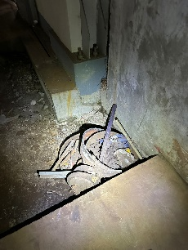 |  |  |  | 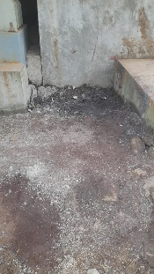 |  |  |  | 1 Juni 2024 |  | Piping |  | Closed
11 | 1 Juni 2024 | Reported by : Munir (HSE)  Hazard Desc: Scrap berhamburan  Action To Do: Perlu housekeeping  Location : 4306 Blower |  | Housekeeping |  |  | 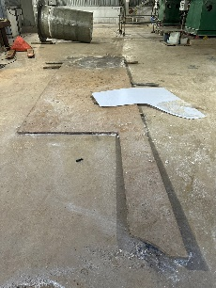 |  |  |  | 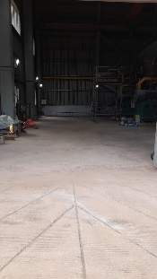 |  |  |  | 1 Juni 2024 |  | Mechanical |  | Closed
12 | 1 Juni 2024 | Reported by : Munir (HSE)  Hazard Desc: Area kerja berantakan  Action To Do: Perlu housekeeping  Location : 4301 |  | Housekeeping |  |  | 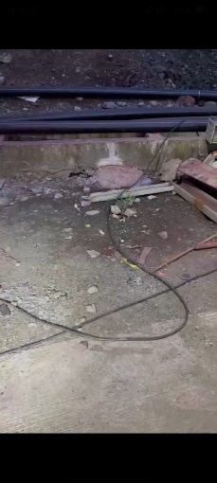 |  |  |  |  |  |  |  | 15 Juni 2024 |  | AGI |  | Open
13 | 1 Juni 2024 | Reported by : Munir (HSE)  Hazard Desc: Material menghalangi akses  Action To Do: Perlu diangkut atau reposisi  Location : 4302 |  | Material Storage |  |  | 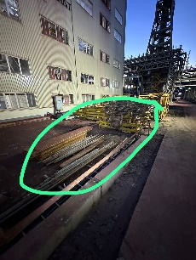 |  |  |  |  |  |  |  | 15 Juni 2024 |  | Risca |  | Open

D | TAHAN REPORT
No | TAHAN Date | Reported By - Dept | Detail TAHAN | Immediate Action Taken | TAHAN Category

E | OBJECTIVE INSPECTION – HSE Patrol
No | Location | Administration  (PTW, JSEA) | Method/ Procedur | Control in Place | Tools/ PPE | Environment | Supervisor Name
1 | 4303  -Install cover tray  -Pulling cable  -Install Support, Lighting  -Install field Instrument  -Install pipe support  -Setting fan blower  -Install & fabrikasi shelter motor fan | OK | OK | OK | OK | OK | -Budi (BMS)  -Pitoyo (AGI)  -Iyes (Civil Building)  -Syamsudin (Mechanical)  -Nasrudin (Mechanical)
2 | 4305  -Install Carbon Pipe  -Install instrument  -Pulling cable & Dressing  -Install cover tray  -Install bridge penyebrangan  -Install kick plate  -Install Fence Guard for Ball Gear Kiln | OK | OK | OK | OK | OK | -Budi (BMS)  -M. Dani (AGI)  -Arif (Mechanical Welder)  -Syamsuddin (Mechanical)  -Andi Hamka (Mechanical)
3 | 4313  -Install Downpipe  -Install pipe support  -Install Valve & killing punchlist  -Pemotongan clading/bondex setting chamber | OK | OK | OK | OK | OK | -Edward (Plumbing)  -Basri (AGI)  -Syamsuddin (Mechanical)  -Iyes (Civil Building)
4 | Piperack 0168  -Insulasi pipa  -Install scaffolding | OK | OK | OK | OK | OK | -Carwidi (Sartco)  -Nur Wahyudi (Agi)
 | 5412  -Terminasi & Glanding Cable | OK | OK | OK | OK | OK | -Dede (BMS)
5 | 4307  -Fabrikasi FRP & Instalation  -Install HDPE Pipe & support  -Install instrument support & conduit & lighting  -Setting OHC | OK | OK | OK | OK | OK | -Sopian (AGI)  - Sowasis (AGI)  - Budi (BMS)  - Syamsuddin (Mechanical)
6 | 4314 & 4524  -Fabrikasi & Install Pipa  -Install support & cable ladder  -Pengecatan Megafoxy Calcine Bin | OK | OK | OK | OK | OK | -Erivin (Piping)  -Suratno (BMS)  -Syamsuddin (Mechanical)
7 | 4306/4402  -Pulling Cable  -Install Cable ladder  -Install Field Instrument  -Instal support & conduit & Bus Bar  -Install support & lighting  -Allignment beam hoist crane  -Install kickplate & handrail  -Install, Fabrikasi & Laminasi FRP Pipe  -Install Spool Pipe & Accessories HDPE  -Install support pipe carbon  -Plester & Acian dinding | OK | OK | OK | OK | OK | -Suratno (BMS)  -Syamsuddin (Mechanical)  -Jendris (Piping)  -Awan (Piping)  -Erwin (Mechanical)  -Agus Malik (Piping)  -Sopian (AGI)  -Darmawanm (Civil Building)
8 | All Chloride (Mobile)  -Install scaffolding  -Painting  -Instal Grounding  -Tightening Bolt | OK | OK | OK | OK | OK | -Aspian (Risca)  -Nur Wahyudi (Agi scaffolding)  -Budi (BMS)  -Rudi (QAQC)

F | HSE DAILY PROGRAM & ACTIVITY
No | Picture | Description
1 | 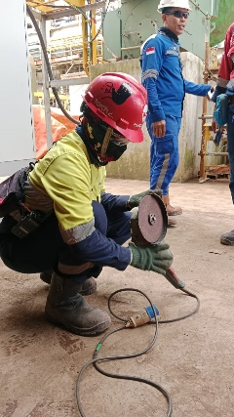 | HSE Program : Power Tools Inspection  Location : Chloride  PIC Report By : : Hartono  Issue :  Recommendation/Action :
2 | 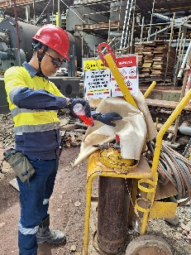 | HSE Program : Oxy Cutting Inspection  Location : Chloride  PIC Report By : : Guntur  Issue :  Recommendation/Action :
3 | 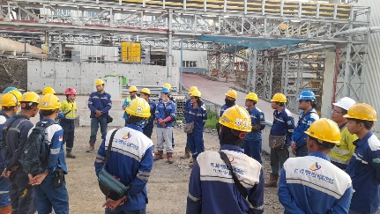 | HSE Program : Toolbox Meeting  Location : Chloride  PIC Report By : : Hartono  Issue :  Recommendation/Action :
 | 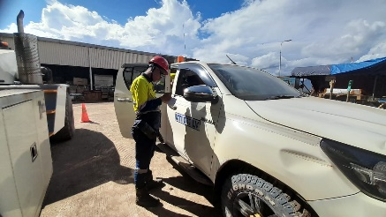 | HSE Program : Spot Check Vehicle  Location : Chloride  PIC Report By : : Guntur  Issue :  Recommendation/Action :
 | 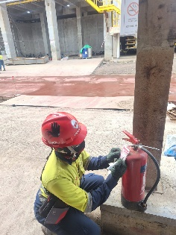 | HSE Program : Fire Extinguisher Inspection  Location : Chloride  PIC Report By : : Guntur/Hartono  Issue :  Recommendation/Action :

G | CORRECTIVE ACTION MONITORING (INCIDENT, INSPECTION, AND ETC)
No | Finding Description | Source | Corrective action taken |  | Due date |  | PIC | Status
1
H | OUTSTANDING INCIDENT COMMENT/ PRELIMINARY
No | Incident tittle | Incident No |  | Incident Type |  | M-Safe Status
1 | A Sledgehammer fell from height and hit a civil crew's back | INC-231124009 |  | SPI Pot. class 2 |  | Waiting for MTI OHS MANAGER approval
2 | Telehandler Manitou TH001’s Tire post 4 Punctured by metal scrap | INC-240512005 |  | Class 3 |  | Waiting for PROJECT MANAGER MMS approval
3 | A Bucket of Paint Got Ignited by Grinding Spark | INC-240512006 |  | Class 3 |  | Waiting for PROJECT MANAGER MMS approval
4 | Scaffolding clamp fell from at height when doing housekeeping | INC-240523011 |  | Class 3 |  | Waiting for PROJECT MANAGER MMS approval
5 | Right-Chest Hit By Sledge Hammer while Tightening Bolt | INC-240531017 |  | Class 3 |  | Waiting for CONTRACTOR Approval
6 | Tail-Light Cover Hit By IBC Tank Frame When Being Repositioned On The Tub of LV 034 MTI | INC-240601001 |  | Class 3 |  | Incident Preliminary Waiting For DEPARTMENT MANAGER Approval

I | HIGH RISK ACTIVITY
No | Description | Permit Number | Area | Total CRM Conduct | CRM By | SPV Responsible
1 | Terminasi Panel & Drawer | - 63/VI/CONT/2024 EV | 4306 MCC |  |  | BMS. Spv : Dede
J | Area of Concern (AOC)
1 | Implemented no barricade, no WAH (included safety sign and watcher)
2 | PPE Policy; it is necessary to emphasize the obligation to use PPE, bcoz it’s often found some workers not wear PPE such as safety glasses, handglove and full body harness
3 | Working at Height; It is necessary to ensure that all controls are implemented correctly and well (fall protection system)
4 | Lifting : It is important to ensure that all controls are implemented correctly and well, such as pre-lift and or Lifting Study (involved safety Team).
5 | Welding work above height : Welding work above the height must provide a work permit, fire extinguisher, fire blanket, fire watcher and barricade area
6 | No Housekeping – No Permit
7 | Falling object prevention: Tools/material bucket must provided and secured on the structure

K | HSE Personnel Status
No | Name | Position | Area | Signature
1 | Munir Muchtar | Superintendent | Chloride Plant
2 | Andrian Silvany | Supervisor | Chloride Plant | Field Break
3 | Donny Aditya | Supervisor | Commissioning
4 | Hartono | Officer | Chloride Plant
5 | Maldi Prasetyo | Officer | Chloride Plant
6 | Kaleb Kurniawan | Safety Man | Chloride Plant (MTI)
7 | Moh. Guntur | Safety Man | Chloride Plant

Reported by, Reviewed by,

(Maldi Prasetyo) (Munir Muchtar)

