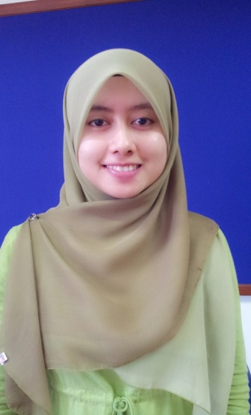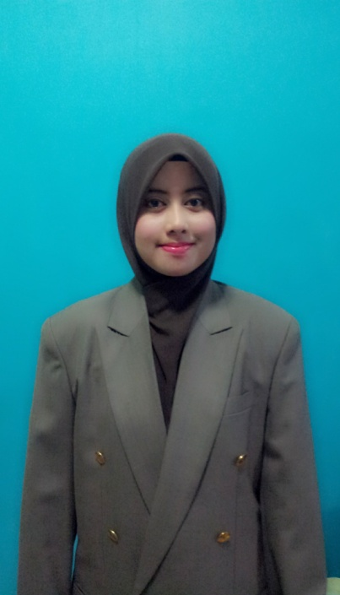**SITI FAIRUS BINTI ABU BAKAR**

The Sanderson Home

Jalan Cemara

Taman Bukit Serdang

43300 Seri Kembangan

Selangor Darul Ehsan.

013-6278341

[ctfayus@yahoo.com](mailto:ctfayus@yahoo.com)

|  |
| --- |
| Education Background Graduation Date |

* Bachelor of Engineering (Hons) Electronics May 2014

Universiti Teknologi MARA (UITM)

Field of Study: Electronic Engineering

CGPA: 3. 71/4.0

* Diploma in Electronic Engineering June 2009

Politeknik Merlimau Melaka

Field of Study: Electronic Engineering

CGPA: 3.88/4.0

* Sijil Pelajaran Malaysia December 2004

Sekolah Menengah Munshi Abdullah

|  |
| --- |
| Work Experiences Date |

* Intern at Enter Corridor Training Center Sdn Bhd Klang Selangor January 2013
* Acquired basic knowledge in PLC (Programmable Logic Controller)

and Pneumatic System

* Drew the circuit by using FPWIN PRO software and

Fluid SIM 3.6h Pneumatic software

* Partime as a Waitress at Intekma UITM Shah Alam Selangor July 2012
* Served guests
* Intern at Konica Minolta Sdn. Bhd. Batu Berendam Melaka October 2009
* Maintained Quality Control (QC)
* Intern at Omega Semiconductor Sdn Bhd Batu Berendam Melaka January 2008
* Checked the ESD (Electrostatic Discharge)
* Installed earth wiring

|  |
| --- |
| Activity Date |

* Participated Industrial Skill Enhancement Program 28 June to

(Computer Integrated manufacturing system) 16 October 2009

|  |
| --- |
| Achivements / Awards |

* Excellent student award (overall & Diploma in Electronic Engineering Program )
* Chancellor ’s award for Diploma
* ’Anugerah Ketua Jabatan’ every semester at Diploma level
* Dean’s list award for semester 1, 2, 4, 5, 6 ,7 and 8 at Degree level
* Scholarship holder by Public Service Department (PSD) at Degree level

|  |
| --- |
| Extra-Curriculum Activity |

* Exco Kebajikan & sosial Jawatankuasa Perwakilan Pelajar (JPP) Politeknik Merlimau

|  |
| --- |
| Profesional skills |

Computer

* Proficient in Microsoft Word, Microsoft PowerPoint, Microsoft Excel, Adobe Photoshop
* Basic knowledge of C Programming, Visual Basic, Matlab and Microsoft Visio, AutoCad

Language

* Excellent in Bahasa Melayu
* Good in English
* Basic knowledge in Japanese language

|  |
| --- |
| Personal Characteristics |

* Dedicated and Committed toward any given task
* Ready to work under pressure and extra hours
* Self-confident, can work independently and a fast learner
* Highly motivated with good communication skills and able to work within a team

|  |
| --- |
| Reference |

|  |  |
| --- | --- |
| Mrs. Norulhuda Abd. Rasheid  Senior Lecturer of electronic department  faculty of electronic engineering  universiti teknologi mara  40450 shah alam, selangor darul ehsan  [nrasheid@yahoo.com](mailto:nrasheid@yahoo.com)  +60192826423 | Mr. Uzer Bin Mohd Noor  Senior Lecturer of Electronic Engineering  Faculty of Electronic Engineering  Universiti Teknologi MARA  40450 Shah Alam, Selangor Darul Ehsan  [Uzer58@gmail.com](mailto:Uzer58@gmail.com)  +60192762021 |