Profile Eka Chandra

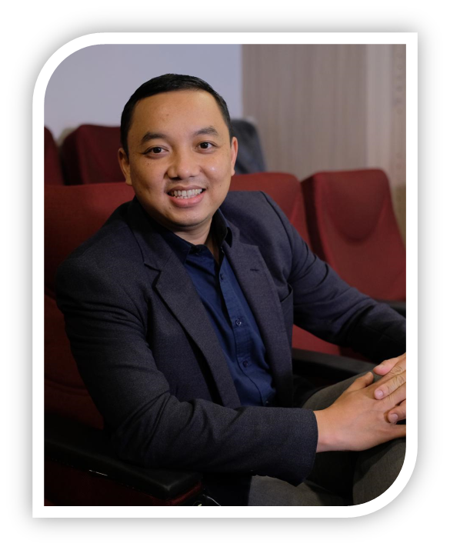
Eka Chandra, ST., CT., CPS., CPEC

Program Director ESQ Character Academy
Head of Trainer Development ESQ Group
Licensed Trainer by DR. HC. Ary Ginanjar Agustian
Certified Trainer by BNSP
Certified Public Speaker by BNSP
Certified Professional Coach Coach by BNSP
Certified NLP Practitioner by ANLPM
Certified Time Line Theraphy by ANLPM

Hp. 0813 2181 1165
email: eka.chandra@esq165.co.id
FB : @Eka Chandra
FanPage : @EkaChandraESQ
IG : @ekachandra165

Personal Details

Full Name : Eka K. Chandra WP
Birth Date : Bandung, 28 Oktober 1980
Marital Status : Menikah
Alamat : Jl. Madrasah 1 no. 107 RT. 03 RW. 06 Pangkalan Jati, Kecamatan Cinere
Kota Depok, Jawa Barat 16513

Pendidikan

- UNIVERSITAS JENDERAL ACHMAD YANI (UNJANI) - CIMAHI
Sarjana Teknik (ST)
Konsentrasi : Teknik Elektro

Specialized In

- Character Building Training
- Personal Transformation Program
- Leadership Development Program
- Corporate Culture Transformation
- Spiritual Motivation
- Service and Communication Training
- Talent Base Coaching Workshop
- ESQ 3.0 Coaching Workshop
- Change Agent and Change Leader Workshop
- Time Line Theraphy
- NLP Practitioner

Pengalaman Kerja

- HEAD OF TRAINER DEVELOPMENT ESQ GROUP (2021 – sekarang)
- PROGRAM DIRECTOR ESQ CHARACTER ACADEMY (2018 – 2020 & 2022 - sekarang)
- AREA REGIONAL MANAGER ESQ SULAMPA (2017 - 2018)
- BRANCH MANAGER ESQ SULAMPA (2014 – 2017)
- HRD REPS ESQ BRANCH SULAMPA (2010 – 2014)
- TRAINER AND CAOCH OF ESQ GROUP (2005 – sekarang)

Pencapaian

- The Best Trainer 2020
- The Best Branch Tahun 2014
- The Best CRO NDD Peringkat 3 Tahun 2014
- The Best CRO NDD Peringkat 2 Bulan Juni 2011
- The Best CRO NDD Peringkat 3 Bulan Agustus 2010
- The Best CRO NDD Peringkat 1 Bulan Agustus 2010
- The Best Trainer Peringkat 1 Tahun 2009

Pengalaman Training/ Workshop/ Seminar

- PERSONAL TRANSFORMATION PROGRAM
- SPIRITUAL REVIVAL BANK INDONESIA
- MITSUBISHI CHEMICAL INDONESIA
- UNIT LAYANAN TERPADU KEMENDIKBUD RI
- PT. PERKEBUNAN NUSANTARA V
- PDAM MAKASSAR
- PEMKOT MAKASSAR
- PEMKOT KENDARI
- PEMKAB KOLAKA
- PEMKOT PAREPARE
- PEMKAB BULUKUMBA
- PEMKAB BATAENG
- PEMKAB JEEPONTO
- PEMKAB PINRANG
- PEMKAB FAKFAK
- BPKP SULSEL
- PT. PELINDO IV
- PT. BANK BNI KANWIL VII
- PT. ANTAM POMALA
- KOPERTIS WILAYAH IX
- PJR POLDA SULSEL
- POLITEKNIK PENERBANGAN MAKASSAR
- POLITEKNIK ILMU PELAYARAN MAKASSAR
- BP2IP MAKASSAR
- UNIVERSITAS HALU OLEO
- UNIVERSITAS ISLAM MAKASSAR
- STIM NITRO
- POLTEKPAR MAKASSAR
- STIKES PANAKKUKANG
- STIKES PELAMONIA
- ATRO MUHAMMADIYAH, DLL

- CAPACITY BUILDING
- PUSDIKLAT MAHKAMAH AGUNG
- PEMPROV SULSEL
- KANIM KELAS 1 MAKASSAR
- PEMKOT MAKASSAR
- KANIM KELAS II KENDARI
- KOPERTIS WILAYAH IX
- ASKRINDO MAKASSAR
- BANK BUKOPIN KCU. MAKASSAR
- LP3TK KPTK
- BPJS KETENAGAKERJAAN SULSEL, DLL

- VALUES INTERNALIZATION
- KEMENKO MARVES RI
- KEMENTERIAN PUPR RI
- KEMENDAG RI
- KEMENAG SULSEL
- KEMENAG SULBAR
- KANIM KELAS 1 DENPASAR
- PT. PELINDO IV
- JNE MAKASSAR
- BANK MANDIRI KANWIL SULAWESI
- BPJS KESEHATAN REGIONAL XII PAPUA
- POLDA SULSEL
- RSP. UNHAS
- BBPOM MAKASSAR – MANADO – KENDARI
- UNIVERSITAS ISLAM MAKASSAR
- BALAI DIKLAT KEAGAMAAN MAKASSAR – MANADO – AMBON, DLL

- PUBLIC SPEAKING
- BNI KCU. MAKASSAR
- UNIVERSITAS NEGERI SURABAYA
- PUBLIC TRAINING MAKASSAR

- SERVICE & COMMUNICATION
- PT. TASPEN KCU. MAKASSAR
- BADAN DIKLAT KEUANGAN MAKASSAR
- BANK DANAMON KCU MAKASSAR
- PERUM BULOG
- MANULIFE INSURANCE

- LEADERSHIP & COACHING
- ESQ 3.0 COACHING SESPIMTI LEMDIKLAT POLRI
- ESQ 3.0 COACHING AKPOL
- ESQ 3.0 COACHING DIKTUK BINTARA LEMDIKLAT POLRI
- PENDIDIKAN ENHANCMENT BAGI PEJABAT VICE PRESIDENT BANK BRI
- LEADERSHIP TRAINING & COACHING DITJEN IKP KEMENKOMINFO RI
- LEADERSHIP DEVELOPMENT PROGRAM PT. PUPUK KALTIM
- LEADERSHIP DEVELOPMENT PROGRAM PT. PUPUK KUJANG
- LEADERSHIP DEVELOPMENT PROGRAM MEGA INSURANCE
- EXCELLENCE PERFORMANCE COACHING AUTO 2000
- ESQ 3.0 COACHING "LEADERS AS A COACH" PT. ADHI KARYA (PERSERO)
- CHARACTER BUILDING & TALENT BASED SINERGY PT. TASPEN (PERSERO)

- CHANGE AGENT/ LEADERS WORKHOP
- KEMENDAG RI
- PT. INDONESIA POWER
- PT. WIKA
- PT. HUTAMA KARYA
- MITSUBISHI CHEMICAL INDONESIA
- PT. BANK SULSELBAR
- PT. MITSUBISHI FILM INDONESIA
- BANK RAKYAT INDONESIA

Pengalaman Internasional

- Training ESQ di Kuala Lumpur Malaysia
- Training ESQ di Perth, Australia
- Training ESQ di Rabat, Maroko
- Training Milionaire Mind Intensive, Singapura
- Haji & Umroh ESQ Tour Travel Mekah & Madinah
- Spiritual Journey ESQ Tour Travel Amazing Aqsho Palestina & Petra Jordania
- Spiritual Journey ESQ Tour Travel Amazing China

