C U R R I C U L U M V I T A E

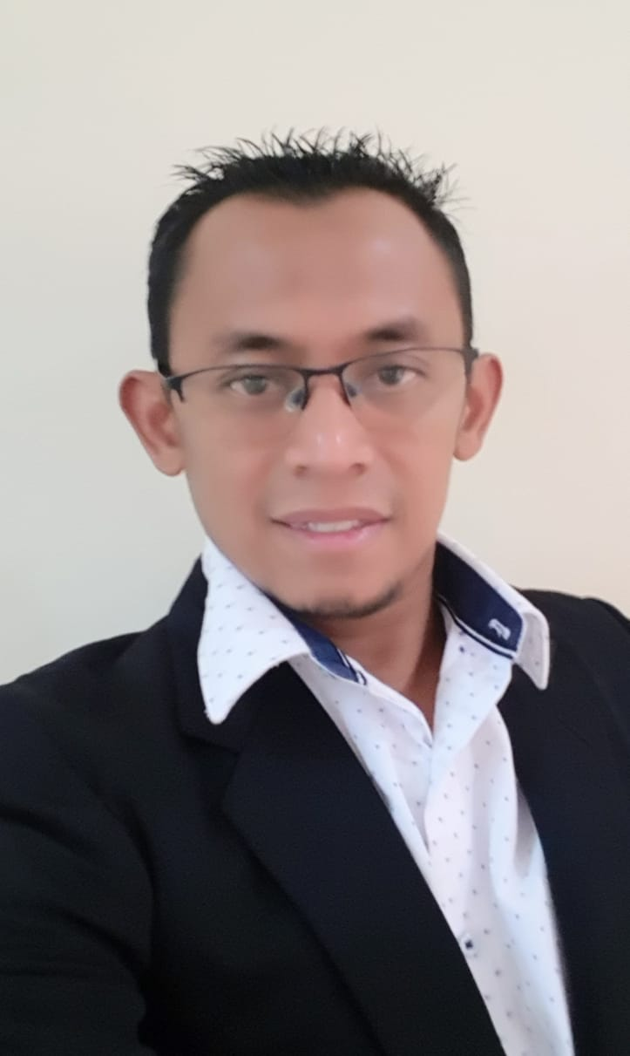

## PERSONAL DETAILS

Name : **Nurman Hadi, S.Kom CHRM**

Address : Jl.Mesjid Al Amsir Rt3/7 no 81

Kel Leuwinanggung – Tapos, Depok 16456

Date of Birth : 7th July 1976

Marital Status : Married

# Telephone Number : **+62 812 800 777 12**

# 

**SUBJECT COMPLETED:**

* Familiar with Networking, Wireless, Assembly Server, Notebook and other new technology for desktop, Server, Workstation, and Notebook
* Familiar with HR Matters, and industrial relationship, recruitment, training, OD, Comben, employee relation policies and having good knowledge of Indonesian Labor law (UU No 13) dan UU Cipta kerja No.6 Th 2023 (Cipta Kerja)
* More than 10 years in managerial level and managed HRGA and Operation department
* Strong analytical skills and experience, with excelent verbal, communicaation skill , training/people development, Industrial Relationship, organization development, comben
* Strong experience in ISO 9001,14001,45001,17025, PROPER, SMK3, IPO Process
* Strong experience dealing with goverments, imigration office, police departement, customs cases, SPSI, YLKI, before and after IPO

###### WORKING EXPERIENCE

1. As a **Trainer** **at** PT. AOWANUSA LESTARI,

Period of Employee : April 2000 – Sept 2003

Report to : Training Manager

**Jobdesk:**

* Planning and implementation training program for sales team and internal staff to develop hard and soft skill
* Make sure sales forces test the skill with hard test or role play periodicly
* Doing observation, interview and detail TNA (training need Analyses) before making/ developing a material training
* Monitorig and Evaluating training and developing material for people / team development
* Doing coaching and counseling for sales forces to achieve sales target

1. As a **Training Development Manager** at PT. AOWANUSA LESTARI,

Period of Employee : Sept 2003 – Dec 2004

Report to : BOD

**Jobdesk:**

* Planning and implementation, evaluating and monitoring training program for sales team and internal staff to develop hard and soft skill
* Develop and design basic to advance training programs, e learning, e testing, e modules, and similiar plans in accordance with finding from training needs analiyses
* Make sure sales forces test the skill with hard test or role play periodicly
* Identify and initiate action steps to improve sales performance
* Doing observation, interview and detail TNA (training need Analyses) before implementation
* Doing coaching and counseling for sales forces to achieve sales target
* Partner with eksternal training / consultan firm to develop specialized training materials
* Travels to other region/ citiesto conduc training courses and field coaching

1. As a **HRGA Manager** at PT. AOWANUSA LESTARI,

Period of Employee : Dec 2004 – Dec 2005

Report to : BOD

**Jobdesk:**

* Support business development and marketing activities
* Control and monitoring about compensation sales and marketing team
* Implement an manage human resources program and employment contracts, regulation law, dispute, organization’s employment policies
* Control and monitoring about people development, training development (hard and soft skill) for sales and marketing or internal staff
* Developing and implement HR strategies and initiatives aligned with the overall business strategy and company objectives
* In charge employee relations, including compensation and benefit welfare, policy socialization etc
* Develop performace appraisal , training and people development for all employee
* Work closely with management and employee to improve work relationships, narture positive working environment and increase employee engagement

1. **HRGA Manager** at PT. Terra Computer System 🡪 PT Tera Data Indonusa (Change the name of company)

Period of Employee : Des 2005 – Oct. 2013

Report to : BOD

**Jobdesk:**

* Control and monitoring about compensation logistic industry
* Implement an manage human resources program and employment contracts, regulation law, dispute, organization’s employmen policies
* Control and monitoring about people development, training developmen (hard an soft skill)
* Developing and monitoring HRMIS and portal HR
* Developing and implement HRGA strategies and initiatives aligned with the overall business strategy and company objectives
* In charge employee relations, including compensation and benefit welfare, policy socialization etc
* Develop performace appraisal , training and people development for all employee
* Handling, negotiatiation solve problem with SPSI/ Labour union
* Work closely with management and employee to improve work relationships, narture positive working environment and increase employee engagement
* as a public speaker to doing Training internal and eksternal (public) to introduce new technology/ programs supported by Principle (intel, Microsoft, Telkom etc) to all cities.

1. **Head Of HRGA** at PT Tigaraksa Satria, Tbk.

Period of Employee : Oct. 2013 – Nov 2020

Report to : BOD

**Jobdesk:**

* Collaborate and work with business partners (internal and Eksternal), Fine-tune and execution to develop and support HR Division
* Collaborate with stakeholders to develop and support operation and busines process trought HR
* Support management strategies and skills uplift plan to address capability gaps in teams and staff
* Adoption plan of new digital technologies to drive enterprise business growth with skilled internal people
* Implement and manage human resources program and employment contracts, regulation law, dispute, organization’s employmen policies
* Control and monitoring about people development, training developmen (hard an soft skill)
* Developing and implement HRGA strategies and initiatives aligned with the overall business strategy and company objectives
* In charge employee relations, including compensation and benefit welfare, policy socialization etc
* Develop performace appraisal , training and people development for all employee
* Handling, negotiatiation solve problem with SPSI/ Labour union

1. **Head of HRGA** at PT Selular Indo Pratama

Period of Employee : Jan 2021 – Nov 2022

Report to : BOD

**Jobdesk:**

* Manage full spectrum of HR Management from Industrial Relation, Talent Management and Development, Organization Development, Learning & Training, HRIS, Compensation and Benefit.
* Manage all aspect of GA: legal compliance, building & infrastructure, security & safety, Expat licenses etc.
* Develop or revise Job Description, Salary Grading Structure, Organization Structure, Competency Standard & Assessment, Performance Management, Training Need & Schedule.
* Propose annual HRGA budget and monitor the implementation of budget.
* Manage our personnel and ensure that our human resources programs and initiatives are effective, efficient, and aligned to overall business objectives.
* Dealing with employee grievances and disputes, supporting employee development, enhancing job satisfaction, designing onboarding procedures, implementing HR strategies that support business objectives, forecasting staffing needs, mitigating risk, structuring benefit packages, maintaining employee records, managing budgets, designing accountability mechanisms, and overseeing overall employment needs.

**Todo list for KPI:**

·       Training Costs: Analyze the investments in your employees.

·       Employee Productivity: Track the overall effectiveness of your workforce.

·       Talent Satisfaction: Ensure your employees are satisfied in the long run.

·       Cost per Hire: Analyze what it takes to find the perfect fit.

·       Recruiting Conversion Rate: Find the best recruitment method.

·       Time to Fill: Monitor how long you need to find a new employee.

1. **HRGA LEGAL IT Manager** at PT. Multi Hanna Kreasindo tbk

Period of Employee : Des 2022 – Present

Report to : Owner/ Director

**Jobdesk:**

* Managing and Develop Human Resources, General Affair (Include Purchasing, asset management), Legal and IT Department – Also Plt Maintenance Manager (since april 2023)
* Planning, implementation and supervision of human resources, General Affair (Include Purchasing and asset management), Legal dan IT Department to improve the quality
* Improving in HR, General Affairs, Purchasing, Legal and IT departments more effective and efficient
* Creating standard operational procedures (SOP) Job description and training and development system and e-learning system
* Developing process of employee recruitment, people development, training development, Industrial relationship, compensation and benefit
* Selecting, promoting, and demotion employees according needs of the Company and making “the right man in the right place”
* Coaching/training and all activities related to the development of abilities, mental potential, skills and knowledge of employees hard/soft skill to the Company's standards competency
* Controlling and administration related to employee absenteeism, salary calculation, compensation-benefits and contract
* Making of permits and monitoring the validity period and making MoUs bipartite or three partite
* Ensure The operational support running well with support IT and GA support including sections such as security the sections, OB / OG, Gardener, receptionist, driver
* Documentation, and update all movable or immovable assets owned by the Company including the Company's facilities and infrastructure.
* Handling all content update and monitoring Digital Marketing, web corporate performance, and all social media (linkedin, Instagram, youtube, etc)
* A Main Committee to preparing for an IPO PT Multi Hanna Kreasindo tbk, handling legal matters, HR matters and IT matters (improvement web corporate, social media and digital marketing)

###### International/ National Event, Awards & Training Programs and others

1. As a **Main Committee for the 4th AOWA INTERNATIONAL CONVENTION event and as a VVIP** Delegation **from AOWA Indonesia** at Hotel Mulia, Jakarta Indonesia, July 20-27th 2002
2. As a **VVIP** **Delegation from AOWA INDONESIA for The AOWA INTERNATIONAL LEADER CONVERENCE as THE BEST STAFF OF THE YEAR 2002** at Hotel Mulia, Jakarta Indonesia, July 26th 2002
3. As a **VVIP** **Delegation from AOWA INDONESIA for the 5th AOWA INTERNATIONAL CONVENTION as THE BEST MANAGER OF THE YEAR 2003** at Kinabalu, Malaysia, (2003)
4. As a **VVIP** **Delegation from AOWA INDONESIA for the 8th AOWA INTERNATIONAL CONVENTION as THE BEST MANAGER OF THE YEAR 2004** at Kuala Lumpur, Malaysia, January 17-24th 2004 and join as a **CANDIDATE IN THE BEST MANAGER INTERNATIONAL CONTEST**
5. **As a Trainer in Workshop Server/ Mobile Certified Engineer Program**, Road show in 20 cities in Indonesia with TCS-Axioo-Rainer Server-Intel-Microsoft- Telkom
6. **Public speaker for seminars and workshops** HR & information technology (in more than 100 university and all cities in Indonesian)
7. As an Executive Member in community of **Trainers Club Indonesia**, (2005- present)
8. As a main committee to preparing for an Initial Public Offering (IPO) PT Multi Hanna Kreasindo

**Reference:**

1. **Rendy Soeyoko, Branded Business Developer, PT Festino Indonesia** (0817194596)
2. **Gita Surya Wijaya, GM - PT Tera data Indonusa /Axioo Plt, LTD** (081288822488)