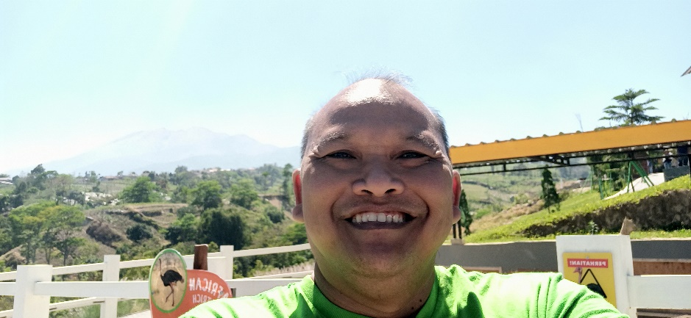

**Gatot Poerwono**

**FIELD HSE COORDINATOR**

Yogyakarta, Indonesia

081915558181

gpoerwono.gmail.com

**Jul. 2000 - April 2008 TOTAL E&P INDONESIE**

***Balikpapan - Indonesia* Environmental Supervisor**

Achievement of ISO 14001 for Handil-CPA Operation

**April. 2008 - present Premier Oil Natuna Sea BV.**

***Natuna - Indonesia* Environmental Supervisor**

Implementation of Company HSEMS

* HSEMS Internal Auditor

**May 1996 – Jan. 2000 BHP/PT. Arutmin Indonesia**

***Balikpapan - Indonesia* Graduate Development Program/Environmental Specialist**

©

**HOBBIES**

**REFERENCES**

**EDUCATION**

**WORK EXPERIENCE**

**Swimming**

**Travelling**

**Culinary Journey**

**Ngudiarto**

Harbour Energy

O&D HSE Superintendent

Phone: 08119703261

E-mail: ngudiarto@harbourenergy.com

**LANGUAGES**

**SKILLS**

* **Indonesia:** Native
* **English:** Fluent

**1995**  **Diploma in Soil Science**

**Bogor-Indonesia** *Institut Pertanian Bogor*