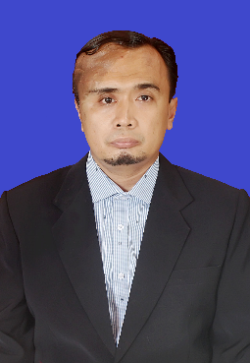**Curriculum Vitae**

**Personal Details**

AJI WIBOWO

Perumahan Griya Permai Blok F1 No. 12 Caringin Legok Tangerang

No. Telp 0811- 1916 – 8802

Email : [wibowoajie2019@gmail.com](mailto:wibowoajie2019@gmail.com)

Adept in analytical thinking, strategic planning, leadership, and building strong relationships with business partners.

Multitasking person and adaptability.

**Education**

* BachelorDegree at mechanical Engineering Gadjah mada University
* Diploma Degree at mechanical Engineering Gadjah mada University

**Employment History**

* Training And Development Manager at PT. Rafitama Millenial Wahyudi (2021 – present)
* Operational Manager at PT. Rafitama Millenial Wahyudi (Jan 2020 – Dec 2021)
* Technical Manager at PT. PT. Rafitama Millenial Wahyudi (Jan 2019 – Dec 2020)
* Workshop Manager at PT. PT. Rafitama Millenial Wahyudi (Jan 2017 – Dec 2018)
* Sales Manager at PT. Nabelsakha Gemilang (Jan 2014 – Dec 2016)
* Technical Supervisor at PT. Nabelsakha Gemilang (Jan 2010 – Dec 2013)
* Project Site Supervisor at PT. Citra Wahyu Diatama (Feb 2007 – Dec 2009)

**Skill**

* Pneumatics hydraulics system
* Leadership
* Computer skill
* Microsoft Office
* English

**Course**

* Leadership Training from Expert Club Indonesia (2023)
* Hydraulics system at BLK Serang (2021)
* Schmalz Academy Training for vacuum handling system (2014)
* Product Knowledge KCC Training from KCC Korea (2011)

**Hobbies**

* Traveling and reading