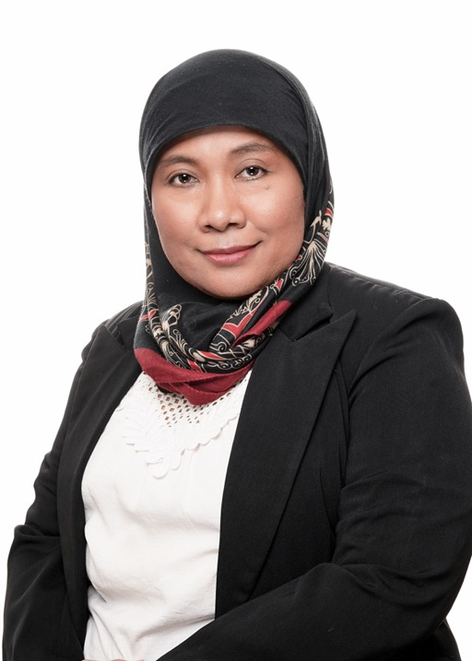 |  |  |  | Yati Afiyanti  BSN, MN, Dr, Profesor  Sexual and reproductive health, Sexuality and Cancer, Gynaecological Cancer, nursing educator & researcher; Lecturer.

Working Experience
1996-now
Faculty of Nursing Universitas Indonesia – Senior Lecturer, researcher, clinical instructor
Responsibilities: teaching, involving in program development, conducting research, supervising nursing student clinical work in the hospital and the community, and supporting the community activities.
Editorial positions:

Editorial board Asian Pacific Journal Oncology Nursing (2015-present)
Editorial board Indonesian Journal of Nursing (2012-present)
Editorial Board Jurnal Ners Media
Reviewer Cancer Nursing (2015- present)
Reviewer Journal of Transcultural Nursing (2020-present)
Reviewer Jurnal Ners (2017- present)
Reviewer International Journal of Nursing Studies (2019-present)

Committees/affiliations
2017-2021 Chair of Indonesian Maternity Nursing Collegium
2015-2018 Chair of Research Division of Indonesian National Nurses
Association
2015-2022 Member of Academic Senate of University of Indonesia
2014-present National Assessor of Higher Educational Institution in Indonesia
2015-present National Assessor of Lecturer certification in Indonesia

Contribution to Science

Sexual nursing intervention for cervical cancer survivors.

Despite its wide range of impacts, sexual issues are mostly overlooked in cancer patients. Among cervical cancer patients and their spouses, the issues are more palpable and complex because of its sociocultural dimension. I investigated the sexual issues among cervical cancer survivors in Indonesia, developed an intervention package, did the implementation, a scale up, and an evaluation. It was the first study regarding sexual issues and intervention for cervical cancer survivors in Indonesia that interestingly opened the eyes to other areas in cervical cancer, not only in supportive care but also in prevention.

2008-now
The field of gynecologic oncology nursing has not yet developed in Indonesia. I started to build my research niche in gynecologic oncologic nursing, especially in cervical cancer in 2009 and have been pioneering this field in Indonesia ever since. My research focus is mainly on the sexual aspect of cancer care, ranging from promotion to intervention. This area is mostly overlooked and is of high importance to crack the taboo among Indonesian society, so that they can be more aware of cervical cancer – the key for the prevention. I have been closely working with the nurses in the National Cancer Centre, hospitals, and primary health centres; gynecologists; midwives – through professional organisations or NGOs. I am currently working to establish the oncology nursing specialist programme that will be the first in Indonesia. Moreover, I have been leading the community engagement projects for promoting reproductive health among women in the community and public schools in Jakarta and West Java since 2004. One of the strategies for this health promotion is by establishing the community volunteers (called kader in Indonesia) focusing on reproductive health. In this proposed project, I am trying to formulate the lessons I have learned in my previous community projects with a strategy that was proven to be successful in polio immunisation programme.

Position Title

Professor

Education Training

University of Indonesia, Indonesia
Degree: Dr. Completion date: 08/2011
Field of Study: Gynecology Oncology Nursing

Memorial University of Newfoundland, Canada
Degree: MN Completion date: 06/2022
Field of Study: Women’s Health Nursing

University of Indonesia, Indonesia
Degree: BSN Completion date: 07/1995
Field of Study: Nursing Science

Publication

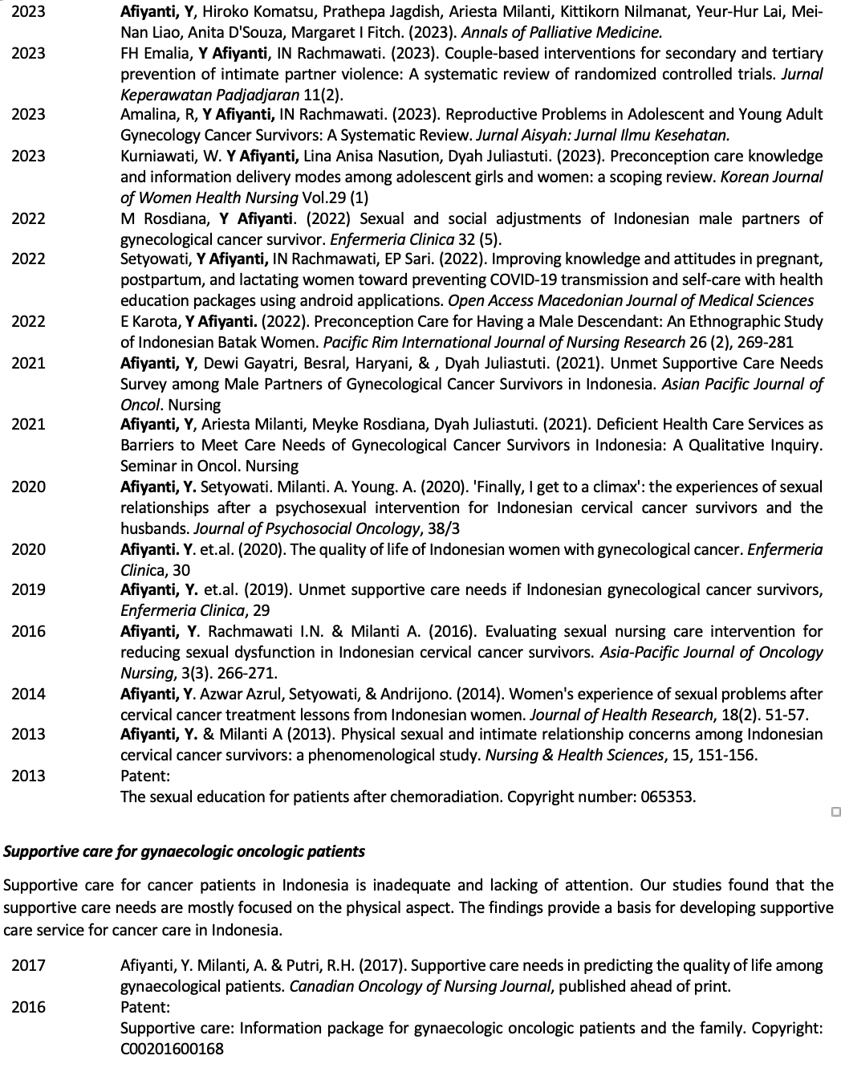

Jl. Sempu Raya no.6
Rt.006 Rw.04 Beji Depok, West Java 16421
 |  | +6281315943320
 |  | yatikris@ui.ac.id
 | 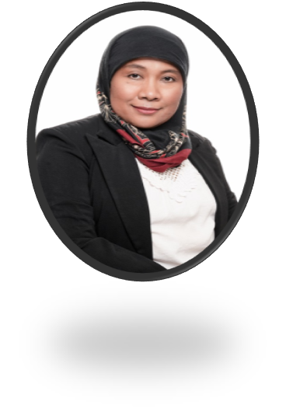
About me
My colleagues call me a hard worker and research expert, and problem solver. Personally, I would describe my-self as an ambitious visionary who enjoy challenge and work hard to achieve goals with excellency.
I am also an active mother who loves indoor and outdoor activities. My goal life is………

Skills
Communication (5/5)
Project management (5/5)
Leadership (5/5)
Microsoft office (5/5)
SPSS (5/5)
NVivo (5/5)

